**Muhammad Abdullah**

**SE(4A) | 19F-0916**

Database Course

Assignment # 5

**PART # 1 SUB QUERIES**

**Q1**

**Q2**

**Q3**

**Q4**

**Q5**

**Q6**

**Q7**

**Q8**

**Q9**

**PART 1 TOTAL QUERIES**

/* Part 1 Queries with Sub Queries */

/* Q1. Display the employee who got the maximum salary.*/

Select *

From EMP1

where SAL IN ( Select Max(SAL) From EMP1 )

/* Q2. Display the employees who are working in Sales department.*/

Select *

From EMP1

Where DEPTNO IN (Select DEPTNO From DEPT1 Where DNAME = 'SALES')

/* Q3. Display the employees who are working in “New York”.*/

Select *

From EMP1

Where DEPTNO IN (Select DEPTNO From DEPT1 Where LOC = 'NEW YORK')

/* Q4. Find out no. of employees working in “Sales” department.*/

Select COUNT(*) as Total_Employees

From EMP1

Where DEPTNO IN (Select DEPTNO From DEPT1 Where DNAME = 'SALES')

/* Q5. List out the employees who earn more than every employee in department 30.*/

Select *

From EMP1

Where SAL > (Select MAX(SAL) as Max_Salary

From EMP1

where DEPTNO IN (Select DEPTNO From DEPT1 where DEPTNO = '30'))

/* Q6. List out the employees who earn more than the lowest salary in department 30.*/

Select *

From EMP1

Where SAL > (Select MIN(SAL) as Min_Salary

From EMP1

where DEPTNO = '30')

/* Q7. Find out whose department has not employees.*/

Select *

From DEPT1

Where DEPTNO NOT In ( Select DEPTNO From EMP1 )

/* Q8. Find out which department does not have any employees.*/

Select *

From DEPT1

Where DEPTNO NOT In ( Select DEPTNO From EMP1 )

/* Q9. Find out the employees who earn greater than the average salary for their department.*/

Select DISTINCT EName,DEPTNO,SAL

From EMP1, (Select Avg(SAL) as AVG_Salary From EMP1 Where DEPTNO In ( Select DEPTNO From EMP1) Group By DEPTNO) T

Group By EName,DEPTNO,T.AVG_Salary,SAL

Having SAL > T.AVG_Salary

**PART # 2 SUB QUERIES**

**Q1**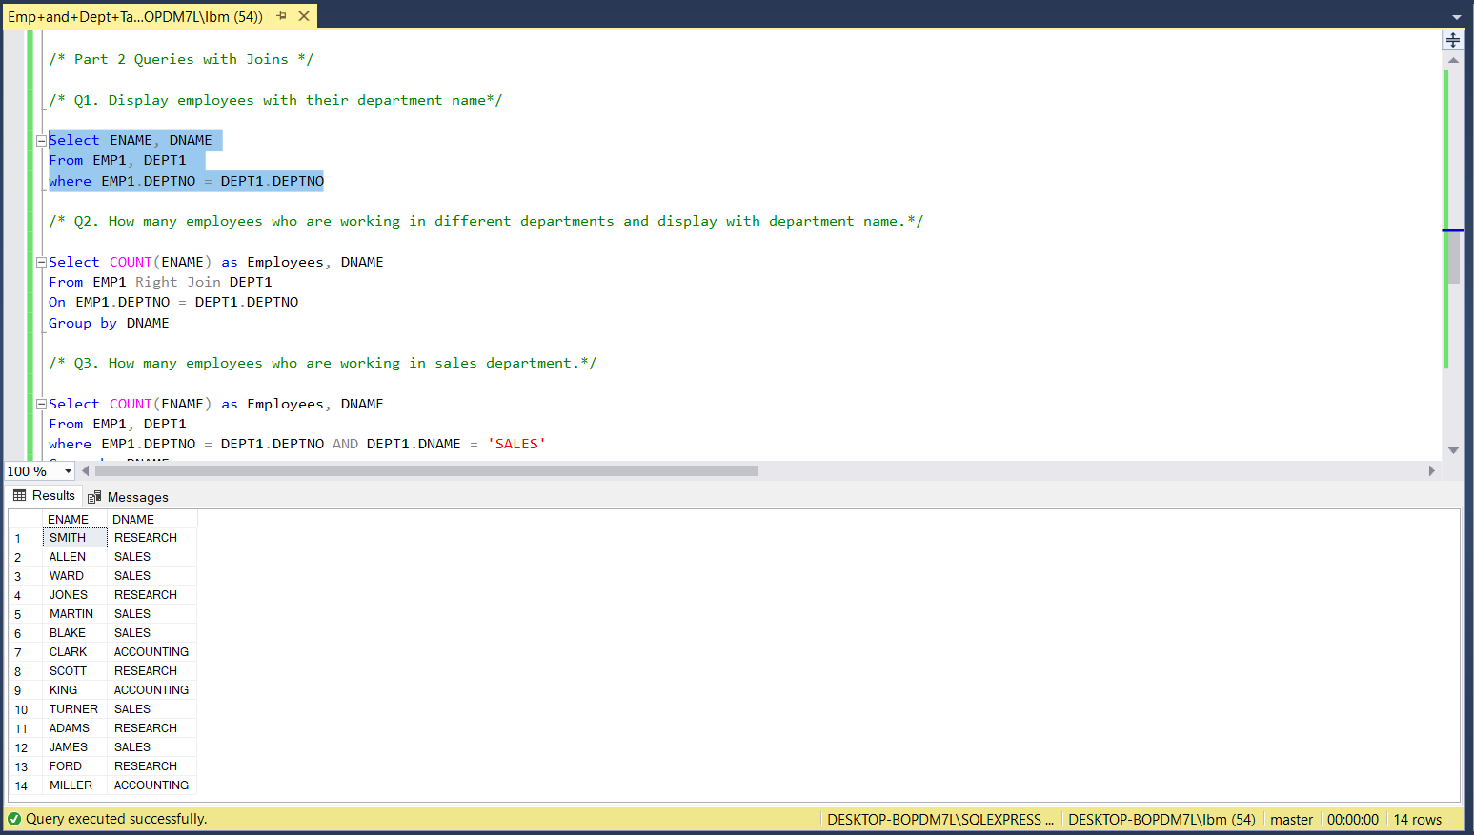

**Q2**

**Q3**

**Q4**

**Q5**

**Q6**

**Q7**

**Q8**

**Q9**

**PART 2 TOTAL QUERIES**

/* Part 2 Queries with Joins */

/* Q1. Display employees with their department name*/

Select ENAME, DNAME

From EMP1, DEPT1

where EMP1.DEPTNO = DEPT1.DEPTNO

/* Q2. How many employees who are working in different departments and display with department name.*/

Select COUNT(ENAME) as Employees, DNAME

From EMP1 Right Join DEPT1

On EMP1.DEPTNO = DEPT1.DEPTNO

Group by DNAME

/* Q3. How many employees who are working in sales department.*/

Select COUNT(ENAME) as Employees, DNAME

From EMP1, DEPT1

where EMP1.DEPTNO = DEPT1.DEPTNO AND DEPT1.DNAME = 'SALES'

Group by DNAME

/* Q4. Which is the department having greater than or equal to 5 employees and display the department names in ascending order.*/

Select COUNT(ENAME) as Employees, DNAME

From EMP1, DEPT1

where EMP1.DEPTNO = DEPT1.DEPTNO

Group by DNAME

Having COUNT(ENAME) >= 5

Order By DNAME ASC

/* Q5. List out the total salary of each department*/

Select SUM(SAL) as Total_Salary, DNAME

From EMP1 Right Join DEPT1

On EMP1.DEPTNO = DEPT1.DEPTNO

Group by DNAME

/* Q6. Display employee details with all departments.*/

Select EMP1.*, DNAME

From EMP1 Right Join DEPT1

On EMP1.DEPTNO = DEPT1.DEPTNO

/* Q7. Display the employee details with their manager names.*/

Select P.ENAME as Manager_Name ,T.*

From EMP1 P Right Join EMP1 T

On P.EMPNO = T.MGR

/* Q8. Display the employee details who earn more than their managers' salaries.*/

Select P.ENAME as Manager_Name ,T.*

From EMP1 P, EMP1 T

where P.EMPNO = T.MGR AND T.SAL > P.SAL

/* Q9. Show the no. of employees working under every manager.*/

Select COUNT(P.EMPNO) as Total_Employees, T.MGR as Manager_ID

From EMP1 P , EMP1 T

where P.EMPNO = T.MGR

Group By T.MGR